Real Growth for New Believers

1 - I want you to see the impact of the Spiritual Starter Kit in peoples’ lives, so that you feel confident sending a new believer to it, to sign up for it.

2 – Jade - Just wanted to say thank you so much for being a part of my new journey.
I love how its called the Spiritual Starter Kit. I always saw myself as more of a spiritual person.
Never thought I’d come to know God like I have. Thank you from the bottom of my heart.

3 – Jose –
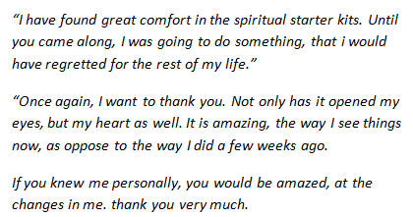

4 – Morgan - “As a teenager, I feel like there is all this focus on getting saved and following the thousands of rules, but I was never given any guidance after accepting Christ….
For months i just went through the motions….
One night, after once again hopelessly trying to understand, I came across this. Thank you, I never would be where i am in my relationship today if God hadn't led me to this!”

5 – Anto - Your kit helped me a lot. Thank you so much. I was just awestruck. Thank you so much.

6 – Rich - I just wanted to let you know how much I am enjoying your
Spiritual Starter Kit. After each one I can't wait for the next one. They are so down to earth. I never realized Christians could be so cool.

7 - “I have enjoyed receiving each and every email from you. I eagerly await anything further you send my way. I know these steps are like that of a baby that I am taking now, but God is real. I know it with all my heart and He is directing my life now and I am so thankful.”

